Shri Sant Gajanan Maharaj College of Engineering, Shegaon
Department of Electronics and Telecommunication Engineering
ELECTRONICS STUDENTS AND STAFF ASSOCIATION

ESSA

Date: 03/102023

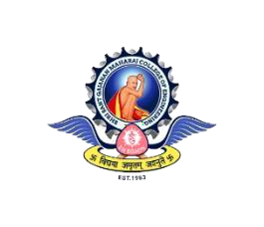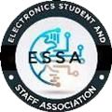

Team | Name
Technical Team | 1.Omika Chaudhary (2U2) 2.Rutuja Gadam (2U2)  3.Saifoddin Shaikh (2U1)
Creative Team | 1.Mansi Paraskar (2U2)  2.Sakshi Dhole (2U1)  3.Sakshi Satao (2U2)  4.Shreya Tayade (2U1)
Publicity Team | 1.Anurag Fulmali (2U1)  2.Shruti Dabhade (2U2)  3.Vedanshu Bhole (2U2)  4.Neha Bhut (2U2)
Program Management Team | 1.Yash Raut (2U1)  2.Tejal Bahirde (2U1)  3.Saloni Magar (2U2)
Resource Management  Team | - Prerana naphade (2U1)  - Akshay Pahurkar (2U2)  - Sakshi Bhojane (2U1)

Prasad Deshmukh | Mrs. K. S. Vyas | Dr. M. N. Tibdewal
Chairperson | Faculty Advisor | Head of Department

